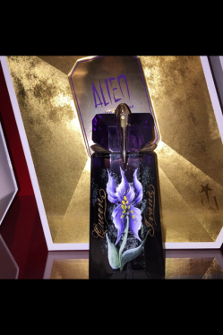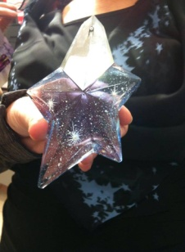
Angel and Alien customers. Join us for some Mugler fun on Friday July 13th& Saturday July 14^{th.}
At 12:00 on both days there will a special show explaining how Angel and Alien were created.
From 1:00 to 3:00 come in and experience the fragrance, without the show.
At 5:00 on both days we will have another special show explaining how Angel and Alien were created.
From 6:00 to-8:00 on both days come in and experience the fragrance and special items without the show. There will be complimentary Mugler samples, Mugler gifts, and delicious treats. Can’t make the event. Come to the fragrance counter and presell prior to the event date, and receive all of the perks without being there. Save the date. Don’t miss this special event. Reserve your seat. Seats are limited. Call fragrance counter 413-538-7360 ext. 2110.
