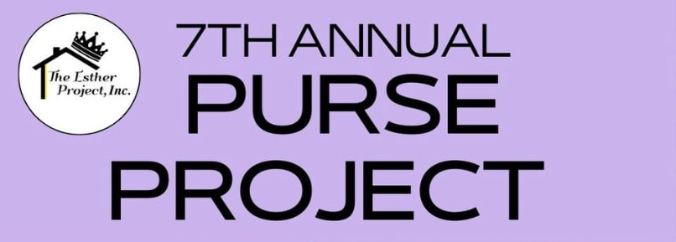
Drop off Full-Sized toiletries now* – September 15 to Vera Bradley (lower level across from elevator)

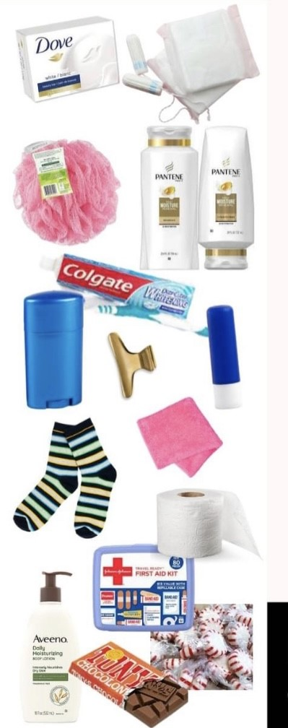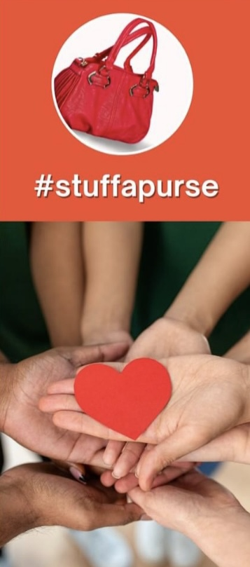
*enter to win a plush blanket of your choice with your donation!

